Target Alpha and Solar City Hybrid EM Conversion

1/15/2022

John Day, Tim Friend, Dave Henry, Scott Richardson

**This project involves lethal voltages and currents and can result in injury, death, fire, or loss of property. Participants who engage with this project understand these risks and agree to indemnify all project members from any claims, losses, expense or liability whatsoever. You understand and agree that the members of this project will not be liable to you or any third party for any loss of profits, use, goodwill, or data, or for any incidental, indirect, special, consequential, or exemplary damages, however arising, that result from utilizing any aspect of this project including but not limited to source code, circuit design and PCBs, circuit assembly or any aspect of hardware or software.**

**Introduction:**

Target Alpha (4 player) and Solar City (2 player) are two of the best drop target EM Pinball machines ever built. The shots are very long and challenging and each drop target has its own insert lamp. These games are a blast to play – until you complete one of the drop target banks and discover that it will not reset during game play. If you have a good ball and knock down all 15 targets you are penalized by having nothing to shoot at – which is the opposite of what good pinball players desire.

There are several reasons why these games don’t reset their drop target banks. The end of ball bonus depends on the state of each drop target as the stepper unit scans each target and awards 1K or 2K for each one which has dropped. The bonus is not accumulated in a separate stepper unit – so if the drop target banks were reset during ball play all of the accumulated bonus would be lost.

The scanning bonus unit is extremely loud, clunky, and unreliable. It is common to see it miscount and deliver extra bonus or miss bonus counts too. Sometimes it mis-sequences and does nothing for one score motor cycle. And it cycles through all 15 targets even if you don’t have any knocked down, delaying the next ball. The objective of this project is to fix all of these issues and substantially upgrade the gameplay while respecting the game’s fundamental EM roots.

**Objectives:**

* ***Retain the game’s fundamental EM roots and allow this conversion to be reversed to a pure EM by a future owner***:
  + Game reset sequence (score motor, AX relay, Score reels, Player Unit, etc.) retained
  + No wires will be cut
  + Any wire which is removed from a relay, jones plug or switch will be heat shrunk and zip tied next to its original position
  + Majority of connections are attached to existing Jones Plug, Relay or switch solder positions.
  + No wiring harnesses are modified or moved in any way
  + No jones plug modifications
* Reset drop target banks during ball play
* Accumulate unlimited bonus and accurately dispense it at the end of ball.
* Upgrade inserts with RGB LEDs which can be controlled in unlimited ways including light shows
* Add solid state “Attract Mode” when the game is idle.
* Have a blast with future game rulesets including target hunts, penalty hits, MP3 audio clips, etc.

**PCB Board Set:**

There are two controller PCBs (Playfield and Relay) which share the same PCB layout but are populated differently and run different code. Both the Playfield and Relay Controller are based on SAMC20E18A microcontroller and communicate with each other through a differential RS-485 bus for noise immunity:

[ATSAMC20E18A | Microchip Technology](https://www.microchip.com/en-us/product/ATSAMC20E18A)

The Playfield Controller PCB is mounted on the playfield and it scans all playfield switches and drives the RGB inserts of the playfield. The Playfield Controller also contains all of the game code and is the controller where most code updates will be applied.

The Relay Controller PCB is mounted on the relay board. It controls the (8) output relays which assert 10s, 100s, 1000s points, reset target banks, sequence end of ball events and trigger extra ball and replay rewards. It also scans the Tilt and Double Bonus relay status so the Playfield Controller can act on these events.

There are (2) 1” and (1) 1.25” spaced (5 count) WS2812B RGB LED boards which light the drop target bank inserts. There are (5) individual WS2812B boards with light the double bonus, extra ball and special stand alone inserts.

**Playfield Controller PCB**

Gnd

Ball Return

Target 15

Target 14

Target 13

Target 12

Target 11

Target 10

Target 9

Target 8

Target 7

Target 6

Target 5

Target 4

Target 3

Target 2

Target 1

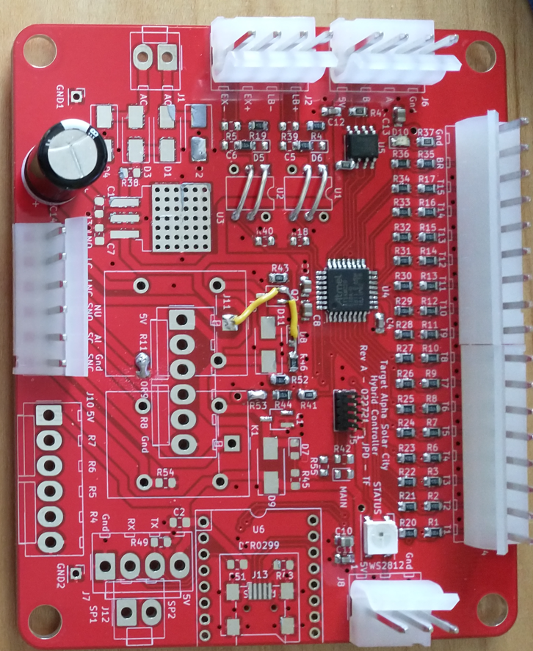

NC

Extra Ball - L

NC

NC

100 Pt

NC

RS485 to Relay

Extra Ball - R

NC

Special - R

NC

Gnd

A – RS485

B – RS485

5 Volts

RGB LED Inserts

Gnd

WS2812 Bus

5 Volts

* RGB Status LED
* (15) Target inputs for drop target status
* (1) Ball return switch input to sense when ball in play has drained
* (4) General purpose switch inputs for playfield targets and roll-overs
  + 100 point target + Pop Bumper
  + Left Extra Ball
  + Right Extra Ball
  + Right Special
* Onboard WS2812B RGB Status LED
* Output to drive WS2812B playfield inserts
* (1) UART output for future apron card OLED display

**Relay Controller PCB**

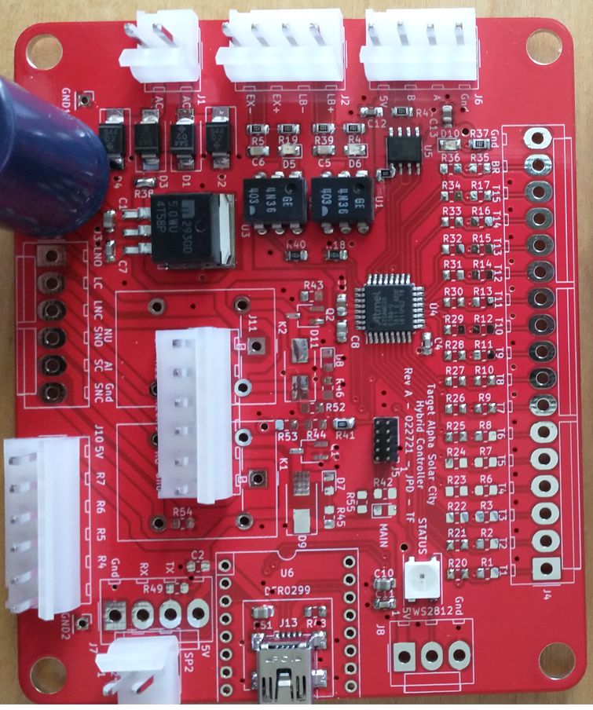

MP3 USB

MP3 Speaker

SPK1

SPK2

5 Volts

5 Bank DT

10 Bank DT

Extra Ball

Special

Gnd

5 Volts

Ball Return

1000 Point

100 Point

10 Point

Gnd

6.3 VAC Power:

RS485 to Playfield:

Relay Coils:

Double Bonus

Double Bonus

Tilt

Tilt

6.3 VAC

6.3 VAC

Gnd

A – RS485

B – RS485

5 Volts

* RGB Status LED
* (8) Relay control outputs:
  + 10 Point Score
  + 100 Point Score
  + 1000 Point Score
  + Ball Return
  + 5 Bank Reset
  + 10 Bank Reset
  + Extra Ball
  + Special / Replay
* 6.3 VAC Input from transformer to power all PCBs.
* Isolated “Double Bonus” Relay state input
* Isolated “Tilt” Relay state input
* DFPlayer MP3 Player with USB connector for file updates

**5 Bank Insert RGB LED Strip:**

The 5 bank target set has 1.25” spacing between inserts. 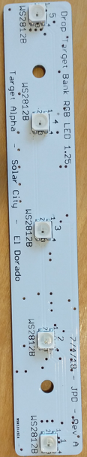

This original lamp sockets are removed and replaced by this PCB mounted in the center of the inserts like this:

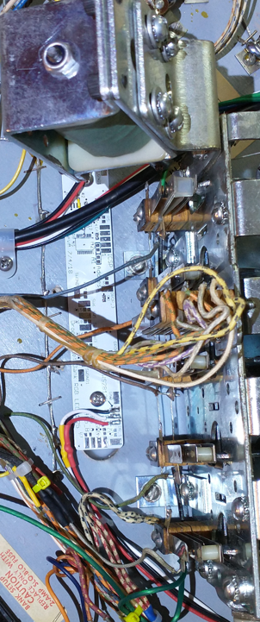

The 5 bank drop target is the first LED strip connected to the playfield controller PCB. The input is on the left hand side of the board Vdd (Red), Gnd (Black) and WS2812B (White) show

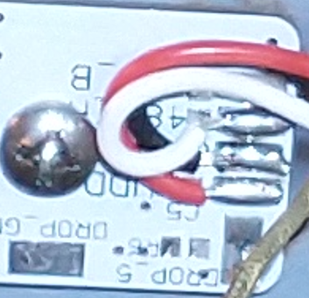

5 Volts

Gnd

WS2812

NC

The output of this board connects to the first 10-bank 1.0” spacing RGB insert board. The output is at the top Gnd (Black), WS2812 (White), 5 Volts (Red)

Gnd

WS2812

5 Volts

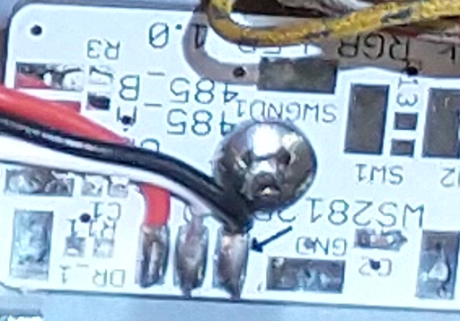

**10 Bank Insert RGB LED Strip:**

The 10 bank target set has 1.00” spacing between inserts.

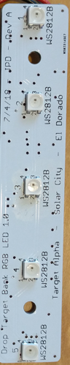

This original lamp sockets are removed and replaced by this PCB mounted in the center of the inserts like this:

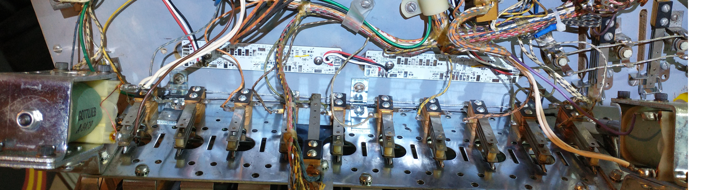

The two boards need to interconnect like this (output on upper right of left hand board connected to the left hand side of the right hand board).

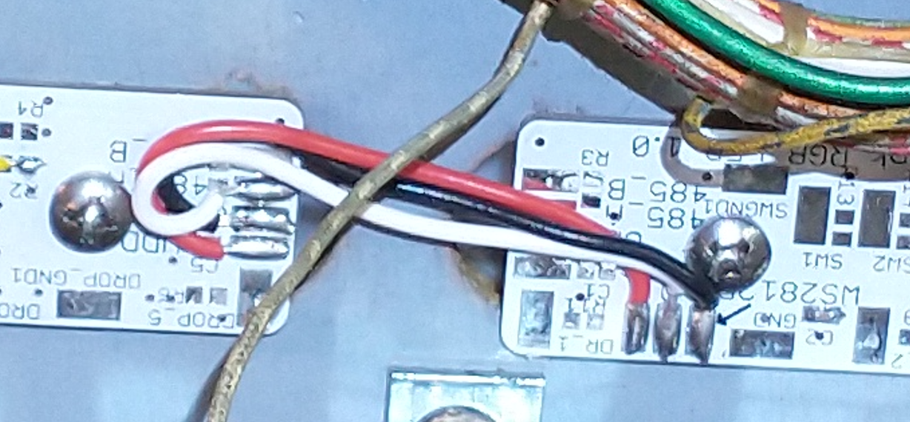

**Individual Insert LEDs:**

The individual insert PCB is mounted under the following locations:

* Left Extra Ball
* Right Extra Ball
* Right Special
* Double Bonus
* Shoot Again

Input

Output

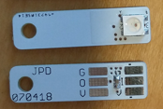

5 Volts

WS2812

Gnd

5 Volts

WS2812

Gnd

**LED Wiring Sequence**

The LED strips (rectangles in this diagram) and individual inserts (circles in this diagram) are wired in this sequence:



**Playfield Controller Mounting:**

All wires are removed from the bonus unit and it is removed. The playfield controller is mounted in the same place as the bonus unit. You may need to relocate the sling shot bracket on some games to create enough space to mount this board.

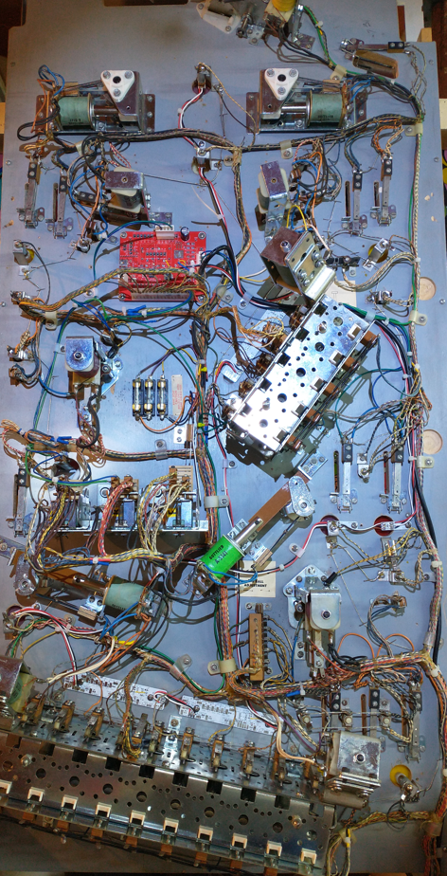

* Remove the 10-bank and 5-bank lamp bracket or sockets, lamps and unsolder the wires from the target bank switches.
* Mount the 1” (10-bank) and 1.25” (5-bank) RGB Strip boards
* Remove the Extra Ball Left, Extra Ball Right, Special, Double Bonus and Shoot Again light bulbs, sockets can remain wired and mounted.
* Mount the single RGB insert PCBs beneath these inserts.
* Using Red, Black and White 22 gauge wire, wire these LEDs per this sequence (See pinouts above along with completed playfield:



* Add 3 pin 0.156” Molex to RGB wiring and plug into the Playfield Controller
* Remove Target Trigger wire from 5-bank and 10-bank. Outer wire remains as this is shared with the 10 point standup switch.

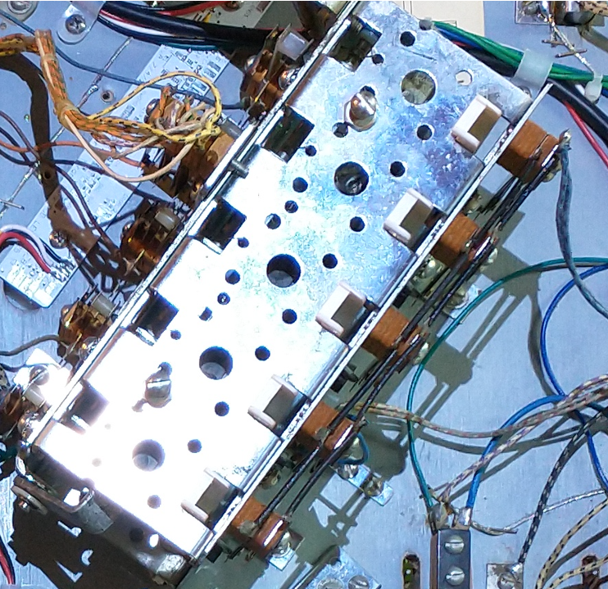

Remove This Wire

* Remove the common wire on the drop target and connect a green ground wire to both target banks. This ground is common to all switch inputs.
* 17 pin Switch Connector:
  + Connect (15) target assertion wires from bonus unit to 17 pin 0.156 Molex connector (see pinout above).
  + Connect ground to all common switch grounds.
  + Connect Ball Return to Ball Return connection from Bonus Unit.
* Connect switch wires to 100 Pts (Both Targets and Pop Bumper Relay)
* Connect switch wires to Extra Ball Left connector
* Connect switch wires to Right extra ball rollover
* Connect switch wires to Right Special rollover

Relay Board Installation

* Mount the Relay Controller next to the transformer as shown below
* Mount the two 4 position relay boards as shown below
* Make two cables with 0.1” 6 pin to 0.156” Molex to interconnect between the relay modules and the relay controller as shown.

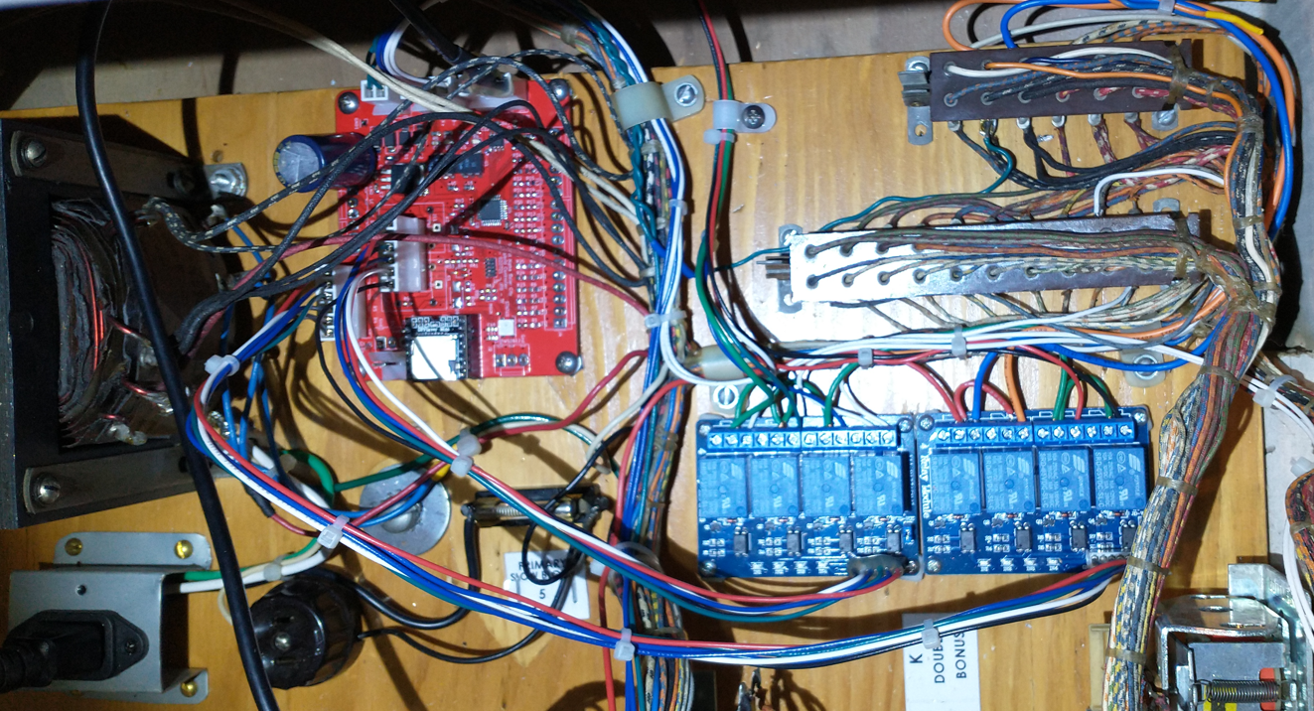

* Connect 6.3 VAC to Upper Jones Plug 6.3 VAC and Tilt Relay 6.3VAC Hot input
* Connect two wires to Tilt relay coil
* Connect two wires to Double Bonus Coil
* Remove double green plastic coated wire from 1st ball relay and shrink wrap and zip tie it
* Connect 18 gauge red 120 VAC wire to the 1st ball relay terminal where these green wires were connected:

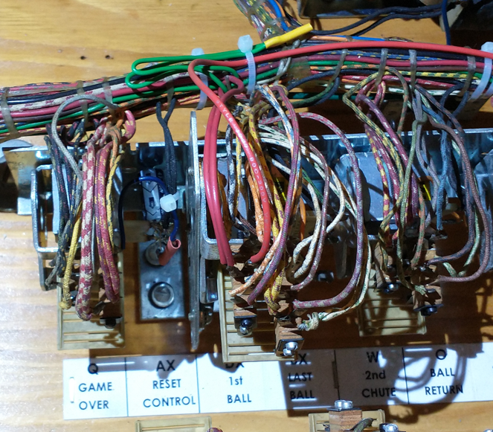

120VAC

* Connect this wire to CT location on 5 and 10 bank reset relays

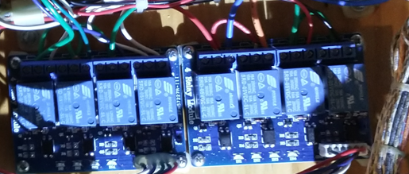

120VAC

120VAC

* Remove the Blue and Orange Wires on the rear Jones plug and heat shrink them.
* Connect the 5 Bank and 10 Bank NO contact to the rear jones plugs as shown with a Blue and Orange Wire

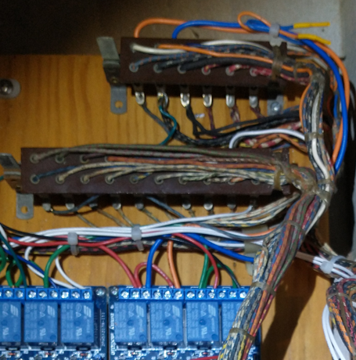

Blue

Orange

Orange

Blue

* Connect Ball Return Relay center and Normally Open to Larger jones plug, leaving existing wire connected.

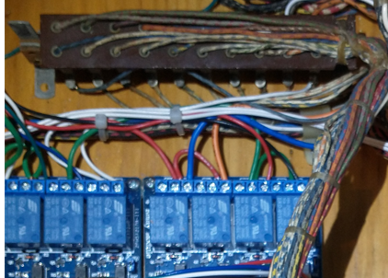

Ball Return

Ball Return

Ball Return

Ball Return

* Open head and connect the following wires to these points on the jones plugs. These wires will be around 1 foot in length and terminate in a 6 pin Molex connector:
  + 18 Gauge Green (common) left row, 3rd down, left plug
  + 22 Gauge White (100s) left row, top, right plug
  + 22 Gauge Blue (1000s) left row, 2nd down, right plug
  + 22 Gauge green (10s), right row, bottom, right plug
  + 22 Gauge Red (Replay), top position of credit adjustment
  + 22 Gauge Black (Extra Ball), bottom position of credit adjustment

White

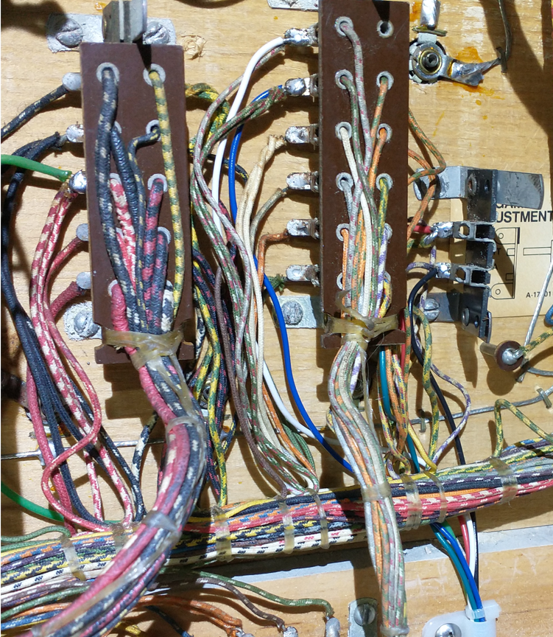

Black

Red

22 Gauge Green

Blue

18 Gauge

Green

* Populate the other side of this 6 pin Molex connector with the same wires and connect those to the relay board:
  + 18 Gauge (common) Green connects to the center of the 1st, 2nd, 3rd, 7th and 8th relays (left to right)

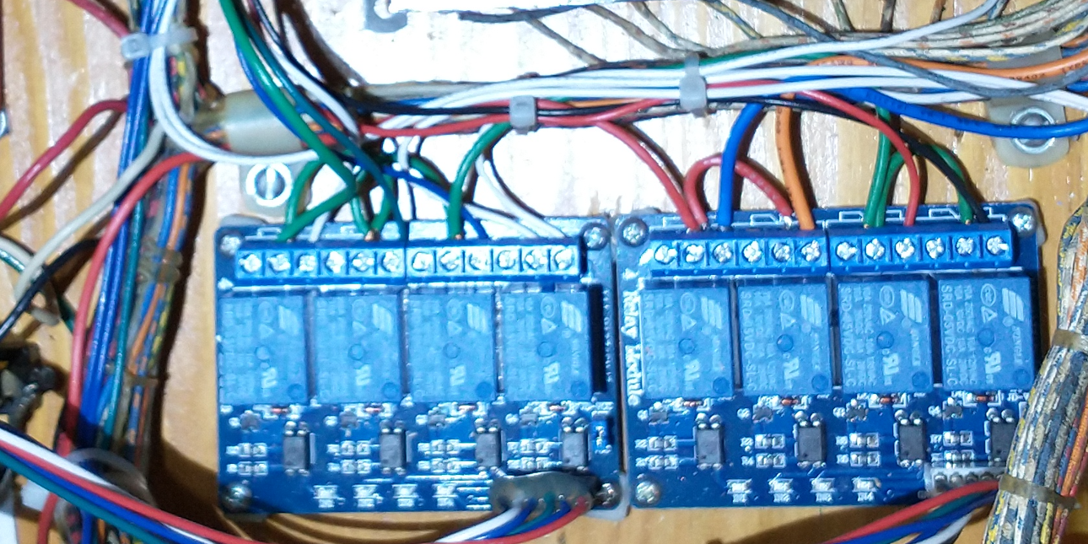

18 Gauge Green

18 Gauge Green

18 Gauge Green

18 Gauge Green

18 Gauge Green

* Connect the following 22 gauge wires to the Normally Open Relay Contacts:
  + White (10s) – 1st Relay
  + Green (100s) – 2nd Relay
  + Blue (1000s) – 3rd Relay
  + Red (Extra Ball) – 7th Relay
  + Black (Special) – 8th Relay



White

Blue

Black

Red

22 Gauge Green